The studio takes a unique approach when compared to existing PCI studios. Our proposed studio will focus on integrating the multiple facets of prefabrication, including materials, design, fabrication, erection and technology into our existing curriculum to systematically expose the future engineers to the concepts of precast industry. This will be achieved by developing and incorporating precast centric modules into our existing curriculum, through multiple classes spanning from sophomore level to graduate level. This studio will be for the first time will integrate precast concepts across three years of undergraduate curriculum and one year of graduate program. Also, this studio will help to showcase the interactions between the various sub disciplines of CCEE program and how they help to shape the success of a prefabrication exercise.
Following are the activities that we did this year (Fall2020 and Spring2021) as part of the PCI studio in our classes.
CE 366 (3 credits): Introduction to Construction Engineering (offered Fall, Spring, and Summer)

This course, which is required for three degrees: Civil, Construction, and ArchE, introduces students to construction and engineering problems; construction management processes and methods in planning, scheduling, and monitoring engineering projects. In addition, students learn to apply engineering economic principles to construction engineering problems. The class meets twice a week in Spring and Fall, and Monday through Friday for a month in Summer.

In the 2020/2021 session, a total of 176 students completed CE 366 across the three semesters.

Students, for the first time, were exposed to the concept of Precast, Prefabrication, Lean and Sustainable construction as part of the introductory course. Dan Eckenrode, Executive Director of PCI Gulf South, led a Precast Concrete 101 session in Fall and Spring semesters, and the instructor covered the content in Summer. Approximately three contact hours (1 week) were allocated to the related and relevant topics and concepts each semester. Some precast-specific Lesson Objectives covered in the class are provided below:

- Describe Precast Components & Systems
- Describe the Different Precast Applications
- Explain the Benefits of Precast
- Explain Design Challenges and Precast Solutions
- Calculate benefit cost analysis of using precast elements

Due to the pandemic, students were unable to visit a precast plant. A visit will be incorporated into the 2021/2022 sessions. Students understanding of Precast Concrete elements and benefits was tested in en exam.

CE 366, Fall 2020. Precast Concrete 101 Lecture.
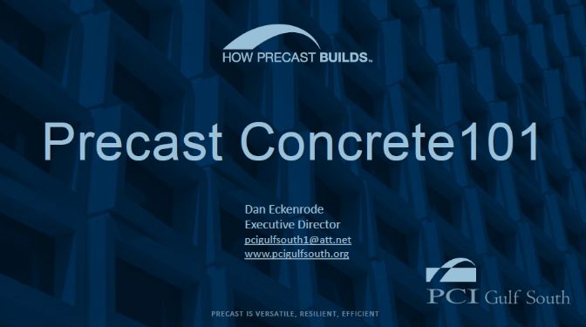 | 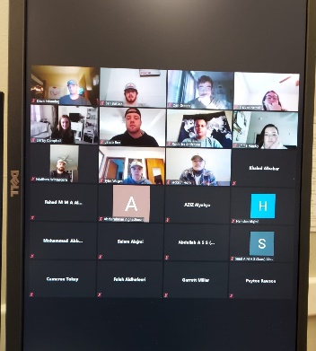

Sample Engineering Economics Problem using Precast Operation as example.
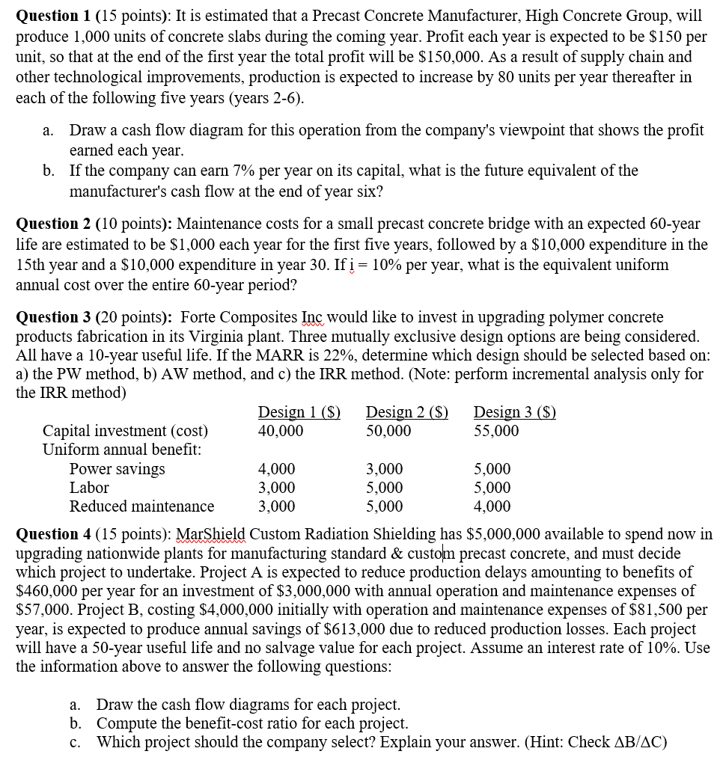

CE 461/CE 561: Horizontal Construction Methods (Fall 2020);
This course is required for Construction Engineering students; this is a 3 credit hour class. As part of the studio, we covered “precast Concrete Pavement” in this class and for the first time ever at UA, we introduced prefabricated concrete pavements into our curriculum. A total of 67 students took this class and they were tested on their understanding of the topic in classroom exam/assignment.
Activity: We presented a lecture on the construction related activities and processes for precast concrete pavements. Resources from NPCA and FHWA were utilized to highlight the challenges and opportunities for precast concrete pavements. A detailed explanation of a precast project in Mobile, Alabama was provided using the FHWA project details and personal experience and discussion with the engineers involved.
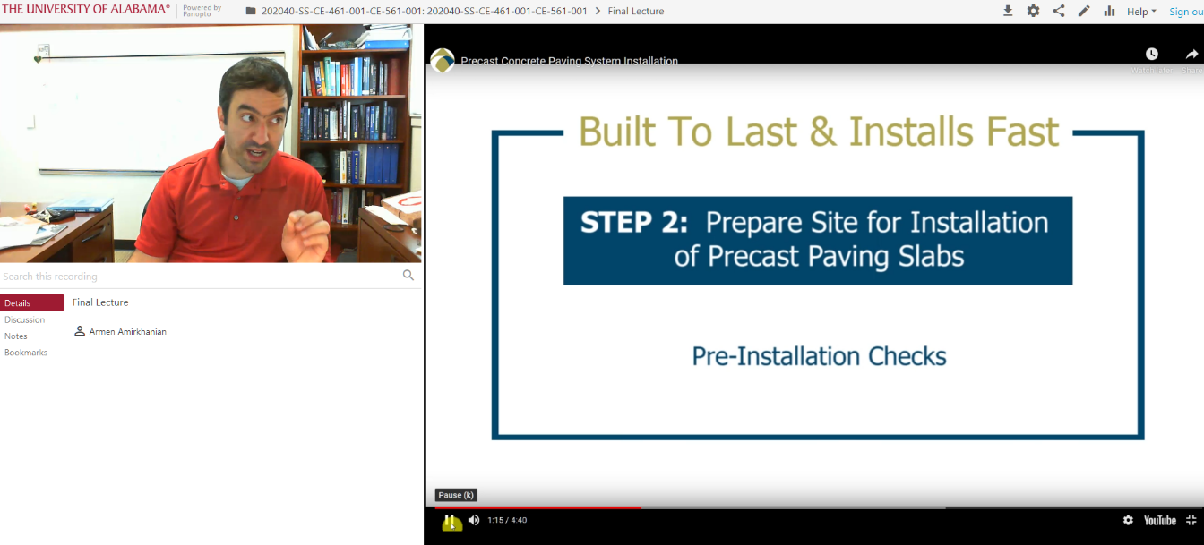
CE 459: Pavement Engineering (spring 2021);
This is an elective course for Civil, Construction and Environmental engineering students. As part of the studio, we introduced more detailed design aspects of precast pavements were covered. A total of 25 students took this class.

Activity: We presented a lecture on the design aspects of precast concrete pavements and how they relate to traditional JPCP and CRCP (concrete) pavements. We focused a significant amount on the dowel bar and joint layouts. We also covered how the better controlled processes at a precast yard can lead to a more consistent and durable product. Resources from NPCA and FHWA were used.
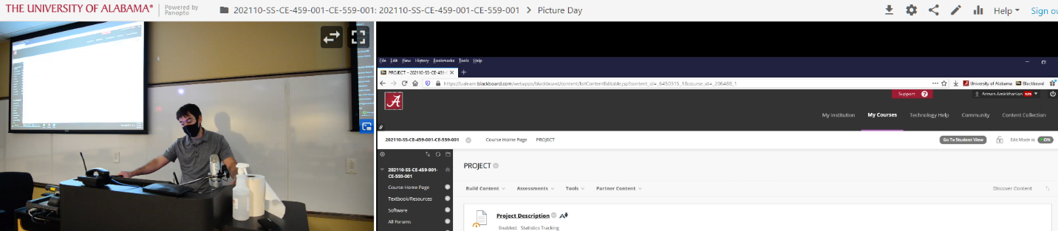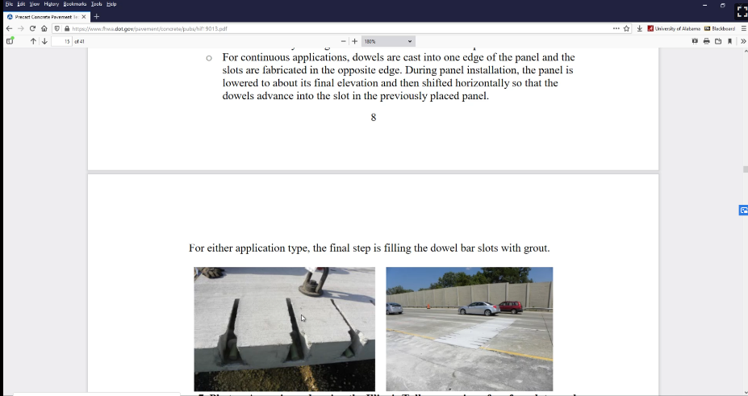
Student Quote: “I had seen this before but didn’t know what it was called or where to find the documentation for it. Thanks for explaining the process and technology”

CE 462/CE 562: Vertical Construction Methods (Fall 2020);
This course is required/elective for Civil. Construction and Architectural Engineering students; this is a 3 credit hour class. As part of the studio, the students spent a week learning about precast concrete construction. The lectures were delivered by professionals from pre-cast industry (Mr. Rob Pavel from Gate Precast). The pictures for the presentations are attached. The students took an exhaustive quiz on the topic (example screenshot of the quiz attached below).
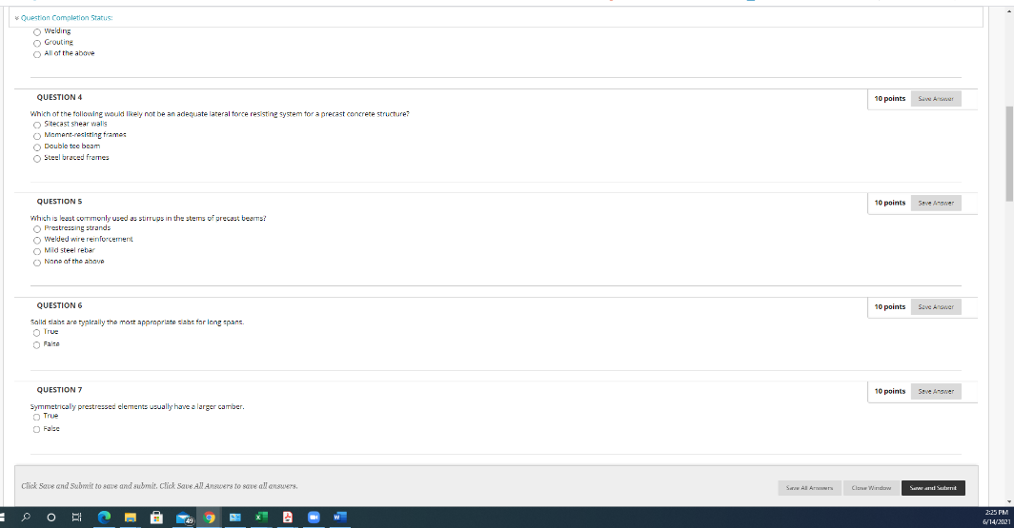
A total of 65 students (61 undergraduate/4 graduate) took this class and they were tested on their understanding of the topic in classroom exam/assignment.
Some relevant comments from the students:
“…he made sure to put emphasis on how the subject matter related to the real world.”
“…His lectures focus on applicable information that I will use in my career.”
For future semesters, we plan to develop a real life cast-study of a precast building, similar to what AISC has done for Steel design curriculum.
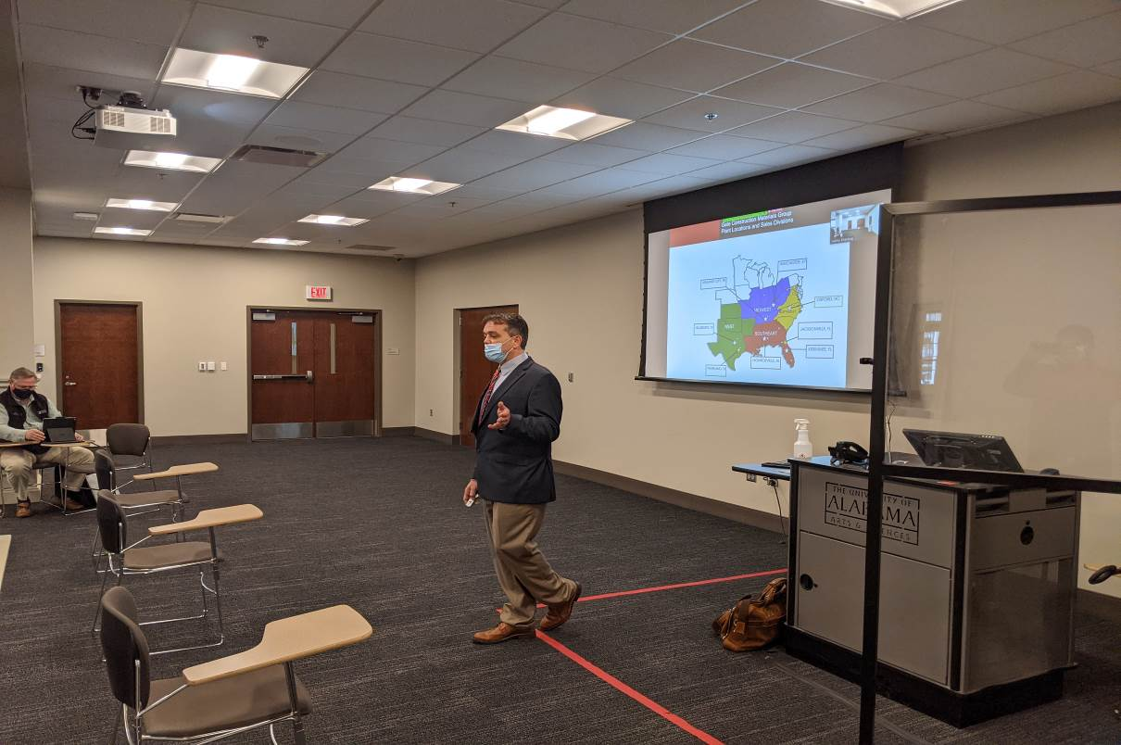
CE 403: Senior Design (Fall2020 and Spring2021); Total students: 80
This is the final year capstone design class. Students use software to design building projects in teams, prepare construction drawings and deliver engineering reports. The course is normally taken during the last term on campus. This course is typically host number of volunteer design practitioners, who will guest lecture to get the students knowledgeable of current industry practice. The projects are real-world projects with requirements. The students design and create a detailed Revit models (renderings) of the structures. Even though, students have routinely used facades in Revit, previously they didn’t do anything with Architectural Precast or precast structures.
This year for the first time, we introduced EDGE software in the classroom with help/support from PTAC consulting engineers. Mr. Jordan from PTAC, gave 1.5 hour lecture (zoom) during both semesters on Precast/prestressed concrete and how to use the EDGE software to draw building structural elements, facades/critical details (screen shots attached below). We also, made students to use EDGE software to draw a façade element.
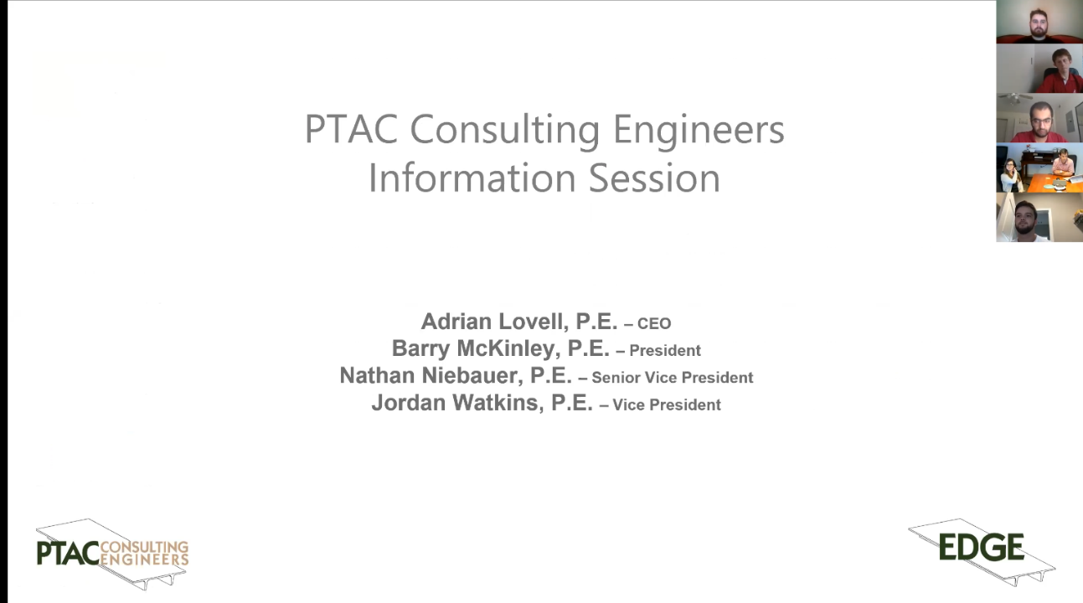
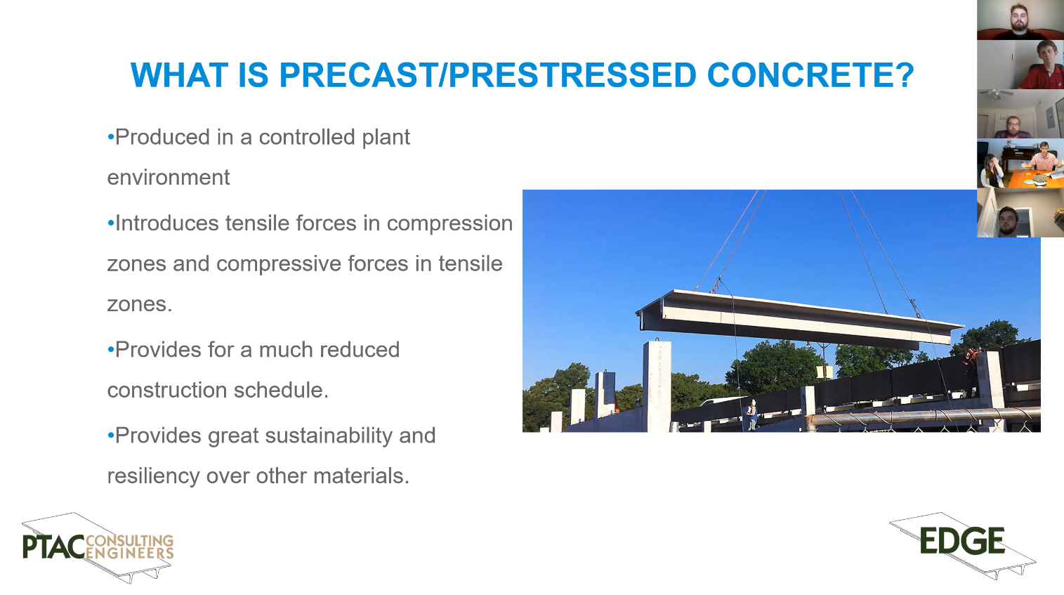
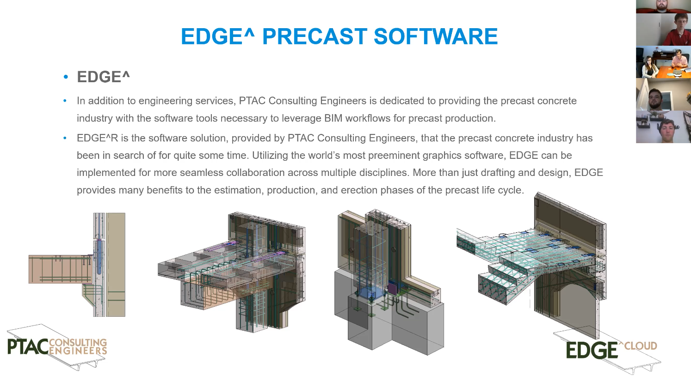

CE 543 (3 credits): Prestressed Concrete Design (Spring2021)
No. of students in this class: ~5
It is a graduate level class. Students learn about analysis and design of prestressed concrete members, review of hardware, stress calculations, prestress losses, section proportioning, flexural design, shear design, deflections, and statically indeterminate structures.
Proposed addition to the course:
- We introduced a design of Double- T beams as part of the classroom design assignments
- We covered PCI design handbook and PCI webinars. Students attended PCI webinars and wrote 1 page summaries.
- The students individually designed a prestressed beam for the PCI big Beam competition. We didn’t get to construct and test due to COVID restrictions. However, we plan to do this from next year onwards.
- The students developed a detailed Excel spreadsheet to do design of Prestressed bridge beams, with standard shapes ( BT, double, NEXT beam, TYPE I to IV).
- We took a sight visit to local precast plant for bridge structural elements (Forterra ®). Pictures attached.

